Questionnaire

I have made a questionnaire to assess what I need to do for my finished device. This questionnaire was then placed on a web site for easy access.
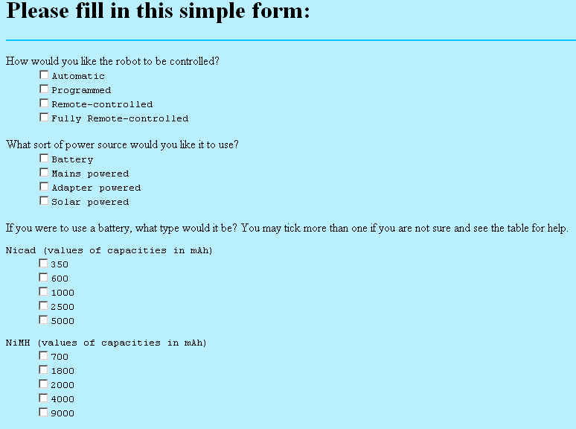

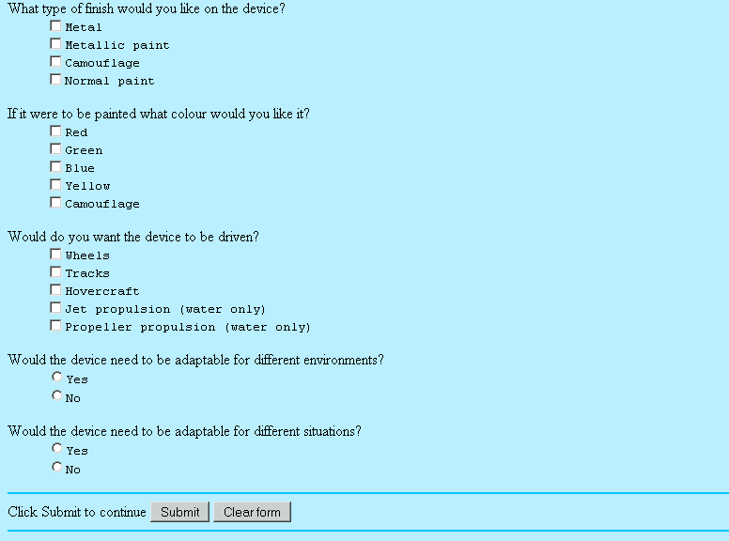

A table was added to help people decide which type of battery they wanted to use.
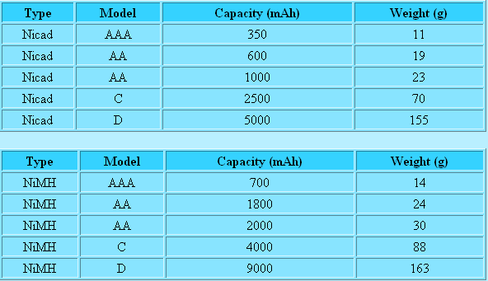
A results table was made from the results of the questionnaire.
Question | Frequency
1 A | 8
1 B | 11
1 C | 8
1 D | 3
2 A | 19
2 B | 3
2 C | 6
2 D | 2
3 A | 1
3 B | 3
3 C | 2
3 D | 0
3 E | 0
3 F | 1
3 G | 12
3 H | 8
3 I | 2
3 J | 1
4 a | 14
4 b | 13
4 c | 2
4 d | 1
5 a | 3
5 b | 13
5 c | 12
5 d | 2
5 e | 0
6 A | 9
6 B | 9
6 C | 7
6 D | 2
6 E | 3
7 A | 23
7 B | 7
8 A | 17
8 B | 13

